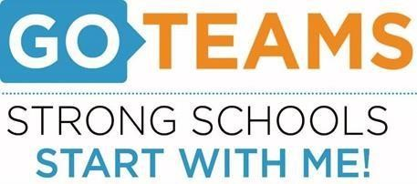

Meeting Agenda
(Agenda may be amended)
This meeting will not allow for Public Comment
Join Zoom Meeting: https://atlantapublicschools-us.zoom.us/j/82681561524?pwd=WVh1TlViejE1aHhtNC8xU0NjR2R3Zz09
- Start Recording
- Call to Order
- Roll Call
- Minutes
- Action Items - N/A
Discussion Items - N/A

- Information Items
  - Spring ACES Review - Ms. Kelley
  - Georgia Milestones – Ms. Kelley
  - MTSS – Mr. Landsman
- Public Comments – N/A
- Announcements
- Next Meeting May 12th – via Zoom
- BEST Graduation – Monday May 24, 2022 @ 4:00pm (Georgia Tech)
- Adjournment

